Springboot filter and security

Spring security internal flow

Servlets and filters

As you know client and server communicate with the help of http requests but our java code doesn’t understand it. Hence to over come this there is a layer added between java code and client that contains servlets and filters. Servlets are responsible to convert http requests into understandable java related objects. Hence servlets are major components of web application.Spring boot internally uses servlets.

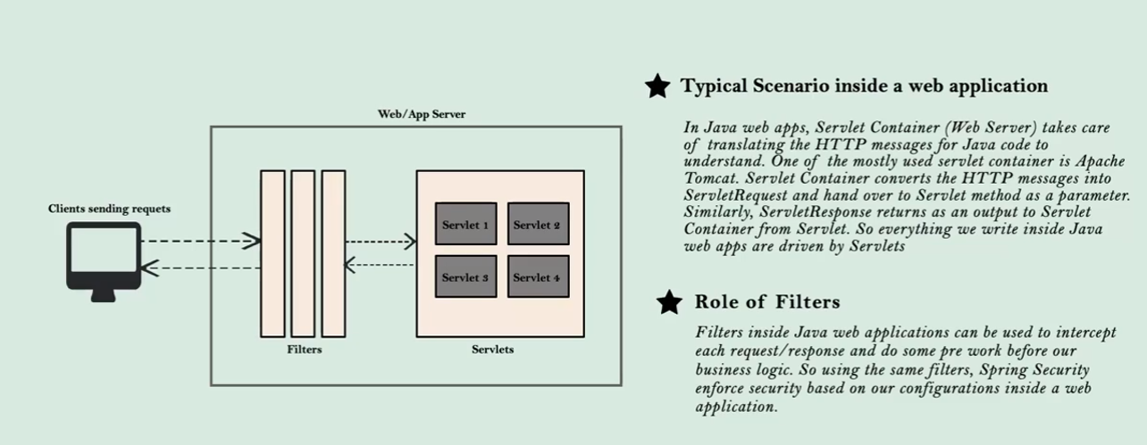

Filters are used to manipulate request / response from or to the client and spring security makes use of these filters and enforce security.

After adding spring security you know that application will provide us with login page and also when we login then we don’t have to re enter username and password again and again. This is done by default configuration.

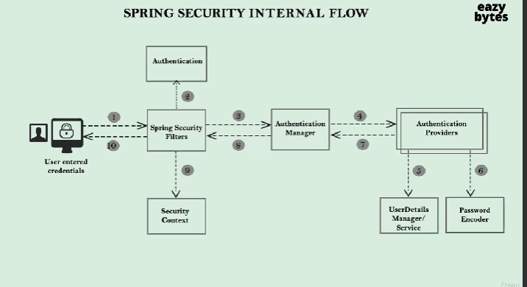

In the above

1. User will send the credentials to the backend server where our application is siting and implemented spring security.
2. As soon as our tomcat receives the request then it is intercepted by the spring security filters to monitor the request. Based on the configuration provided spring security allows the user to access the web page else it enforces authentication. Spring filters also will extract username and password and convert into authentication object as in step 2. Then it is handed over to AuthenticationManager.
3. AuthenticationManager is class that manages the actual authentication logic. It checks what all Authentication providers inside the web application ie whether validate user from DB / Inmemory / oAuth authentication as in step 4. If any authentication provider is failed then it tries with all the available providers.
4. Authentication providers can be configured and can be multiple providers. Also we can use spring security provided userdetails manager / userdeailsservice. Whenever we are authenticating then its obvious that user details from the DB should be managed and stored somewhere so that we can compare with input. So userdetailsmanager takes care of it.
5. Password encoder If we donot want to handle plain text passwords then password encoder encodes the password and store in the cache. So original password will not be revealed.
6. Next once the user is validated by authentication providers then security filters before sending reponse to the client will store the authentication object information in security context like session id, status hence next time it wont ask credentials.

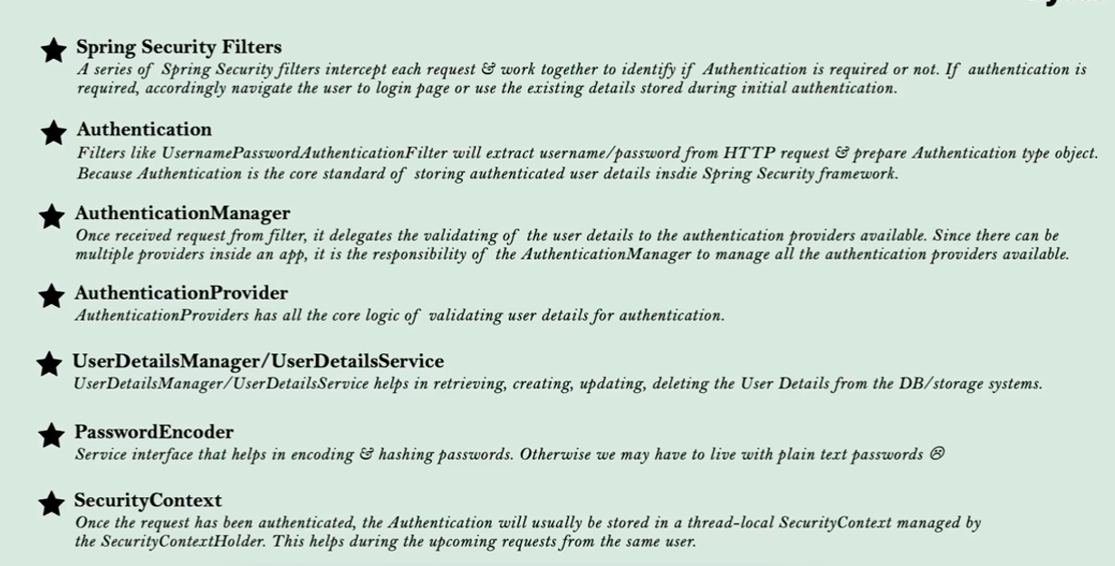

By Default spring security provides the configuration as below where all the incoming requests are authenticated we can change this by implementing our own configuration. Default config file is SpringBootWebSecurityConfiguration as below

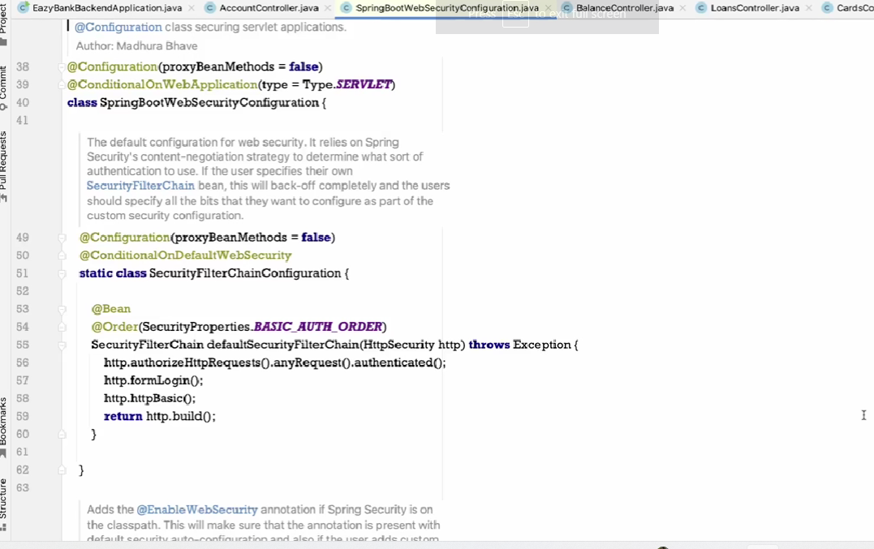

Authentication providers

UserDetailsService/Manager are the interfaces that are used to implement the logic involved in retrieving the user details from DB UserDetailsService contains one method loadByUsername and UserDetailsManager that extends UserDetailsService contains various methods createUser updateUser, deleteUser, changePassword, userExists

Spring developers also has provided some of the implementation of these interfaces like InMemoryUserDetailsManager, JdbcUserDetailsManager. To represent user details spring developer also provided with interface UserDetails where it represents the details of the user and implementation class is User.

Below is the very basic way of providing security to our web pages it shows the login page for authenticated requests it was done with in memory username and password now will see user from DB authentication

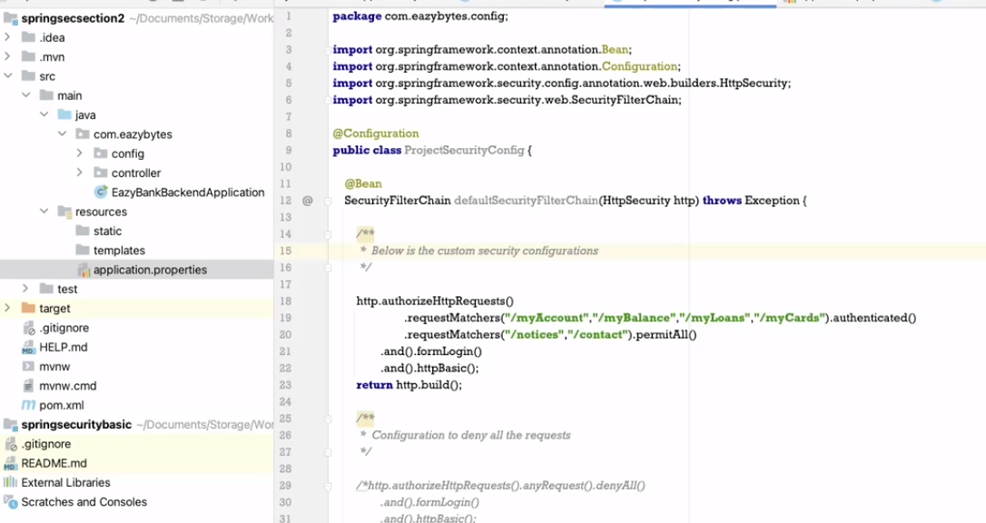

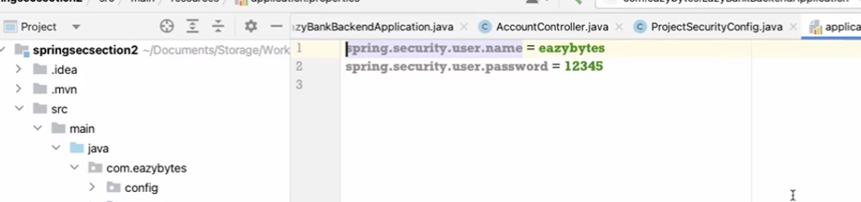

**We can** also define multiple users for in memory authentication but this is not recommended for production

InMemoryUserDetailsManager is a class that implements interface UserDetailsManager. It has constructors that can accept any number of arguments.

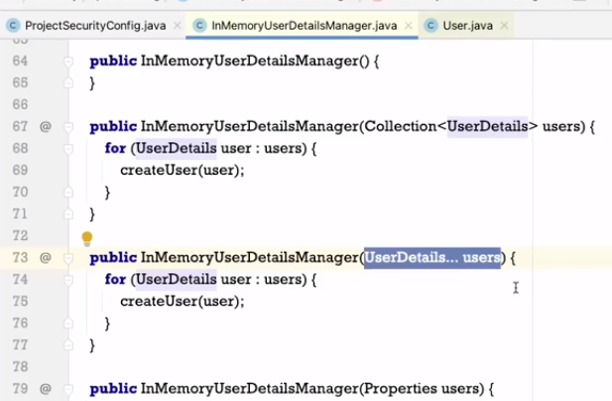

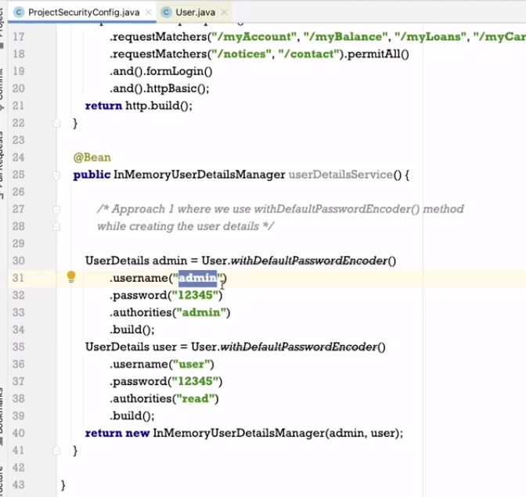

User is a class provided by spring security framework will know more about it later when you build the project and run you will see below page add the admin credentials you will be logged in

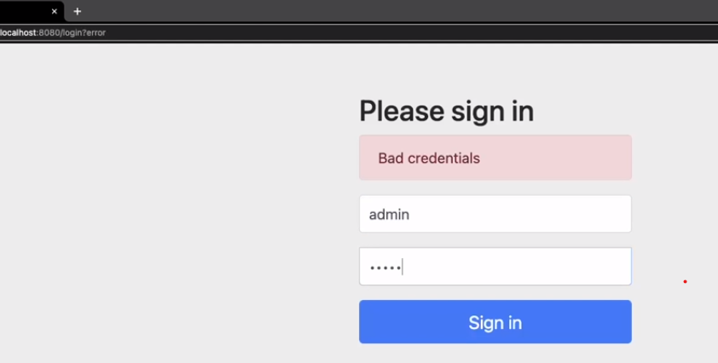

If we don’t want to perform password encoder then we can go with below approach please check code on github section3

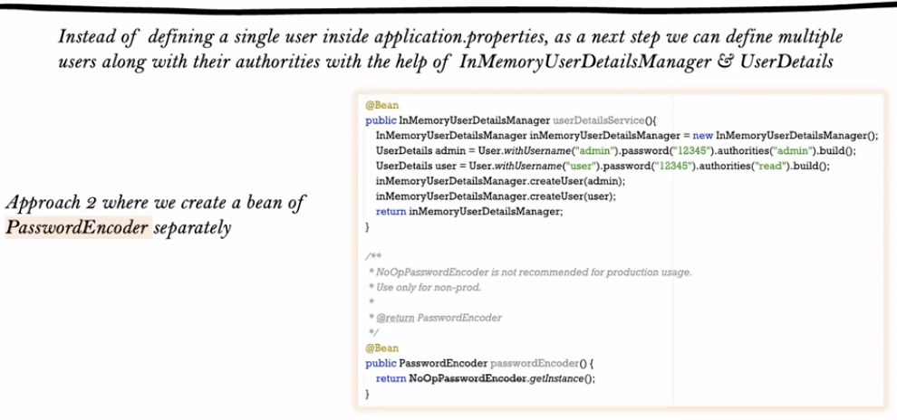

Custom configuration to permit and authenticate the API’s

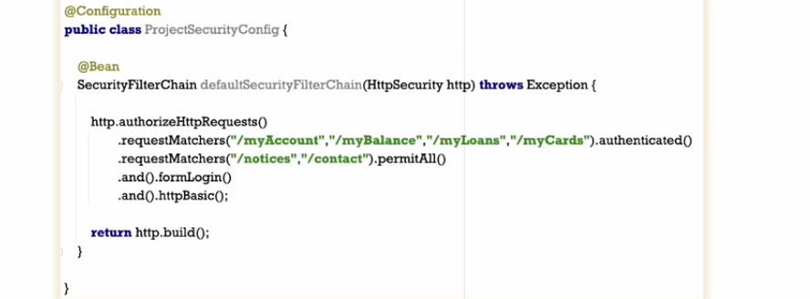

JdbcUserDetailsManager

For JdbcUserDetailsManager Authentication provider we need to compulsorily maintain the Users table in the DB with columns id username password and enabled. For this we need to add Spring jdbc, DB driver(H2/mysql), Spring data jpa then add the properties in application.properties

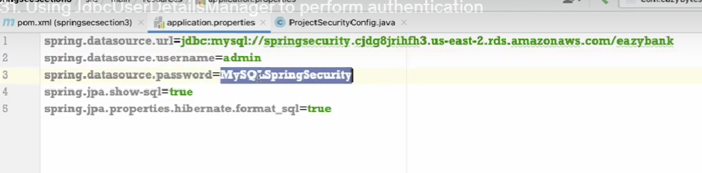

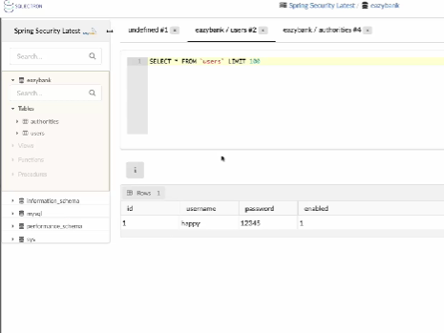

Now create a class with @configuration and add method that returns bean of type JdbcUserDetailsManager as below Authentication provider will automatically query the record from DB and authenticates the user also password encryption is necessary to secure the passwords

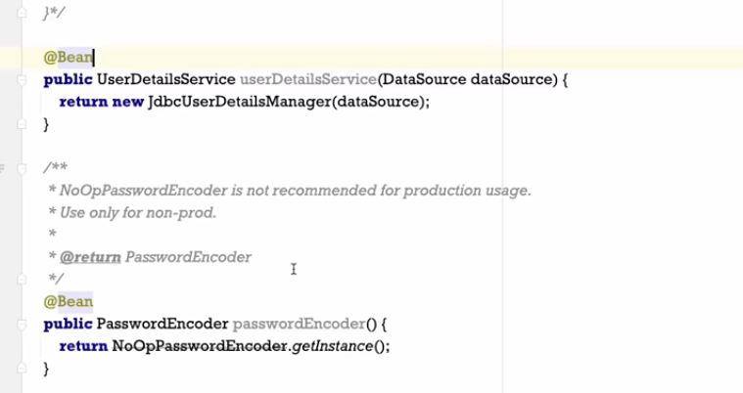

Drawback of JdbcUserDetailsManager is we need to strictly use users table oly. To use customize table we need to implement our own Authentication provider

Custom table customer

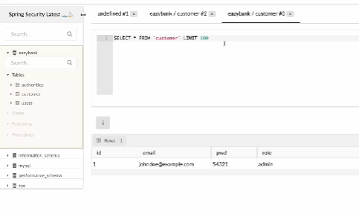

Create Entity customer

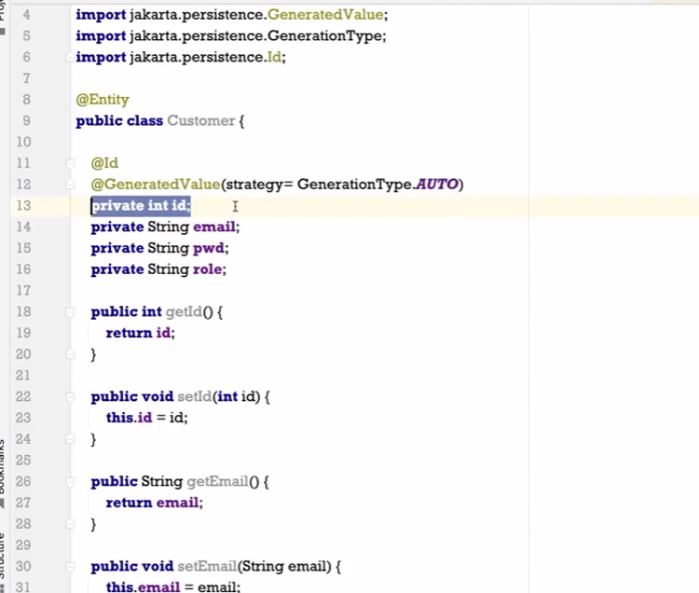

Create repository that fetches the details by email as below

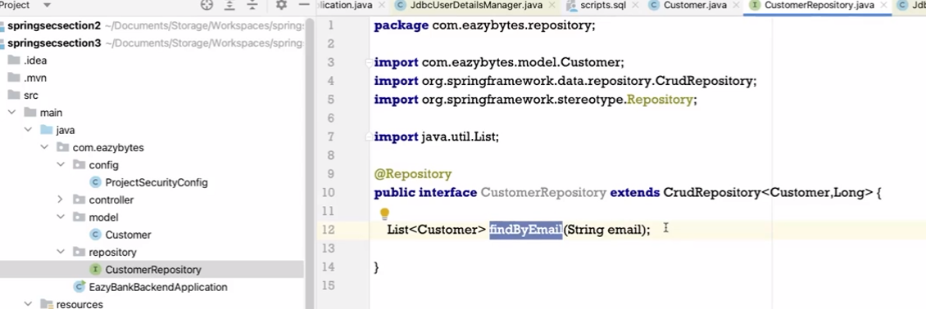

Now lets define custom authentication provider

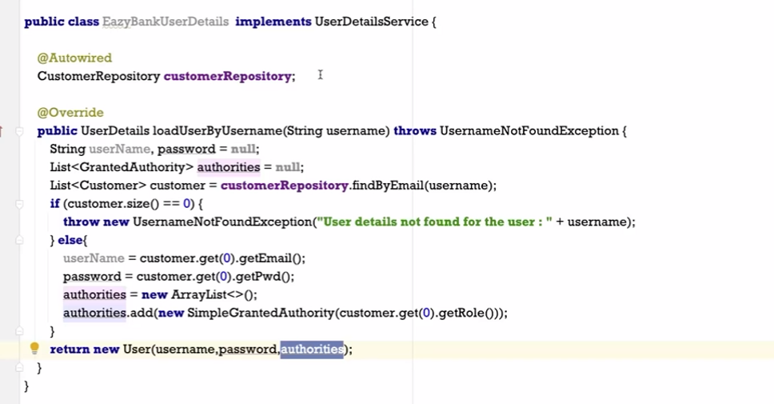

Default password validation by spring security

Storing of plain text password is not recommended. Even in DB we need to store in encrypted fromat

There are three ways to store the password Encoding, Encryption, Hashing

Encoding is done based on normal encoding like base64 , ASCII, Unicode and we decode as well easily

Encryption is done based on key and Encryption can reversible using key. But here key needs to be secured.

Hashing is done based on some Hashing algorithm and here data cannot be reversible. User entered plain password is again hashed using same algorithm based on the arbitrary output of the hashing algorithm matching is done but not with original data. Internally it uses hashcode for generating hashvalue

Spring security has provided us with interface PasswordEncoder which is responsible for encoding the password entered by user

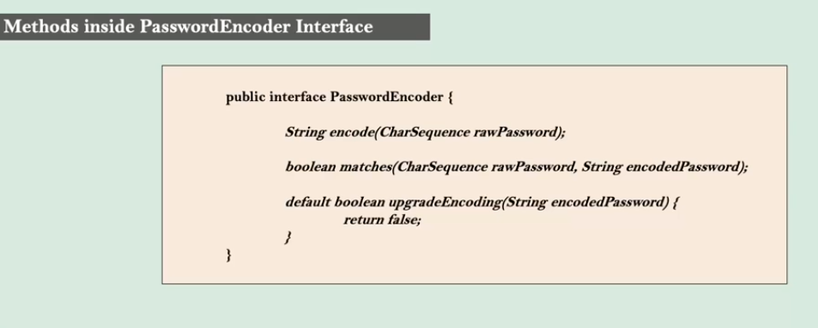

Matches return either true or false after comparing the hash values. rawPassword is converted in hashvalue and compares with provided encodePassword from DB

There are many implementation of PasswordEncoder provided by spring security as below

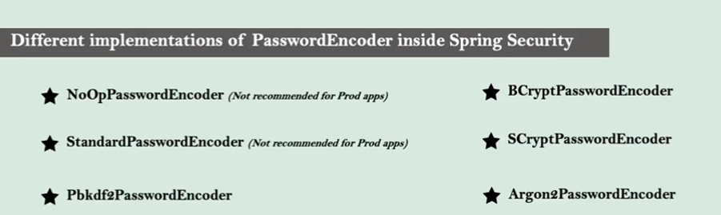

BcryptPasswordencoder is most widely used hashing algorithm

Lets implement the passwordencoding using BCryptPasswordEncoder

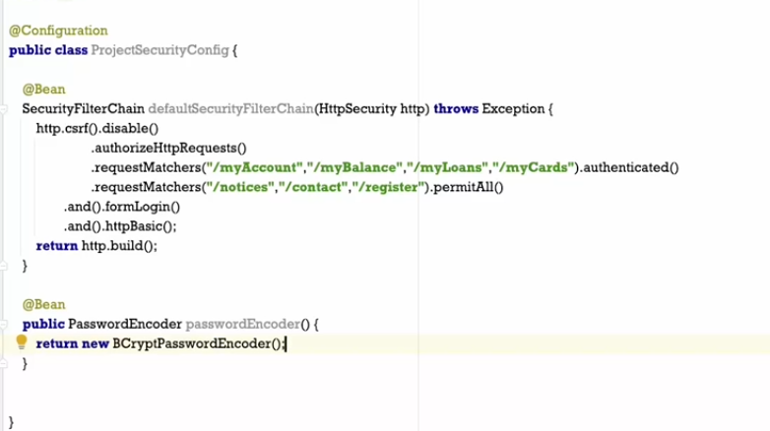

Now lets leverage this password encoder during registration process bcoz user enters an plain text password which needs to be converted into hashing encode password and save in DB

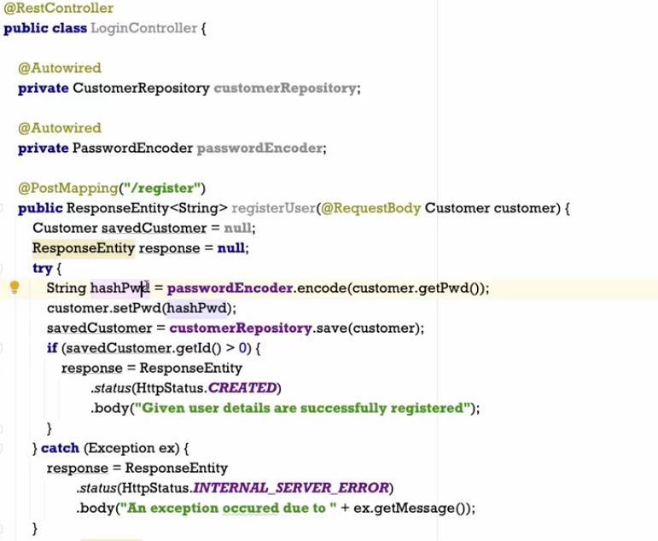

After encoding password is saved in DB

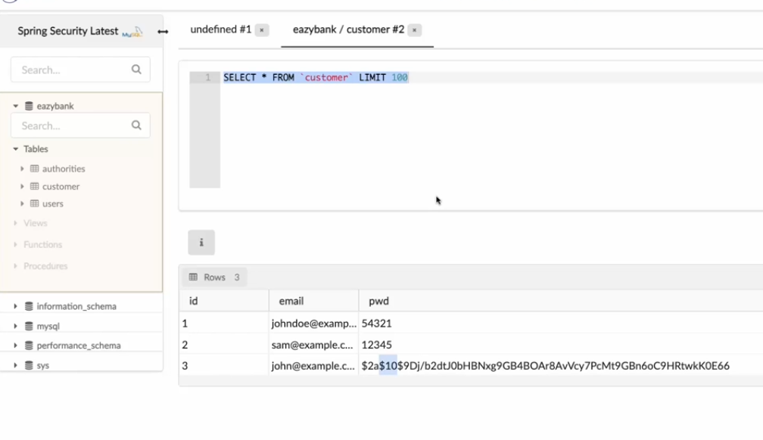

The default authentication provider in spring security is the DaoAuthentication provider which validates the user based on only username and password. But what if we also want to validate OTP or oauth in such cases  we need to implement custom authentication provider

The authentication provider interface contains two methods support and authenticate, authenticate methods take Authentication object which contains username and password from users built by filters

Using support method we are telling what type of authentication needs to be provided ie by username password or OTP or Oauth2

With custom Authentication provider we no longer need to implement UserDetailsService class as will not be using Default Authentication provider that is DaoAuthenticationProvider. We have created our own Authentication provider as below

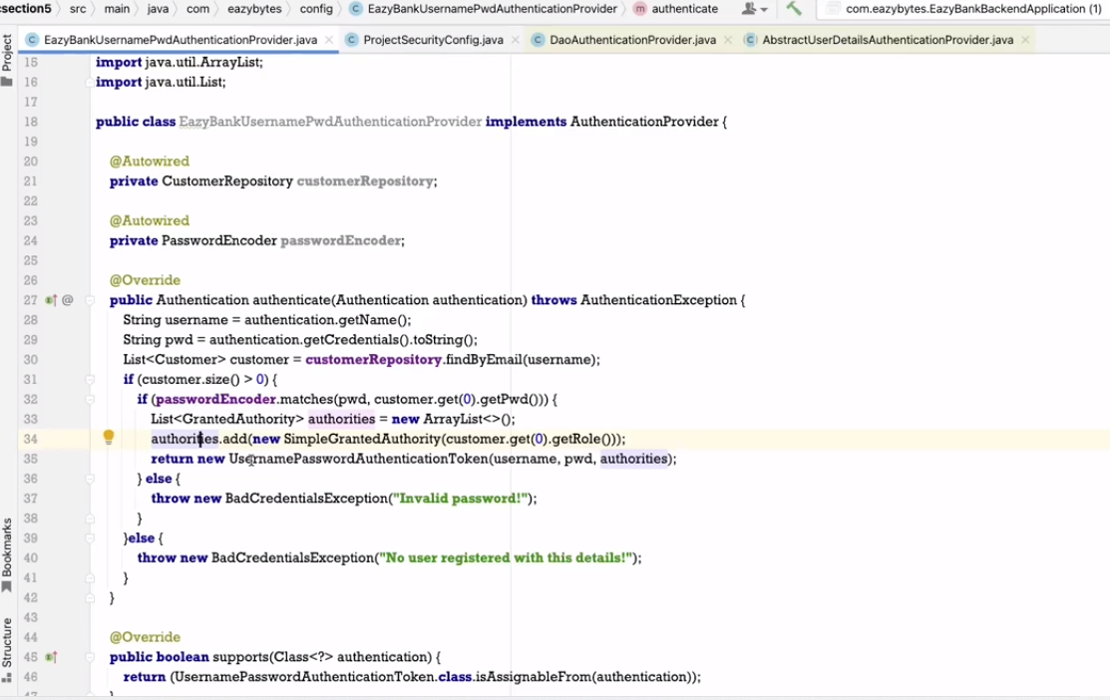

CORS issue

Cross origin resource sharing

UI client and Backend server are two different resources which are trying to communicate since their origin will be different as UI and backend server are running on different server and port. In modern web browsers will block communication with error CORS issue. To over come this issue we can add annotation to each REST API and to tell the backend server to allow such requests coming from that domain as below we can also allow all the requests irrespective of any domain using asterisk “*” as below

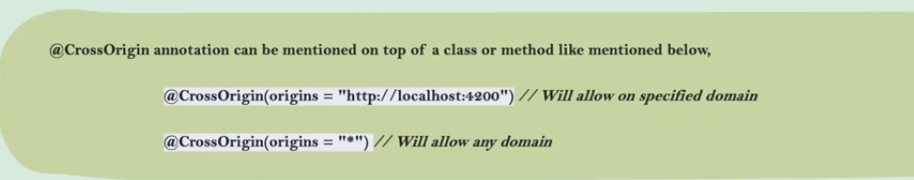

But in real world there will be hundreds of API adding annotation to all API is cumbersome process we can do it globally by providing cors configuration as below

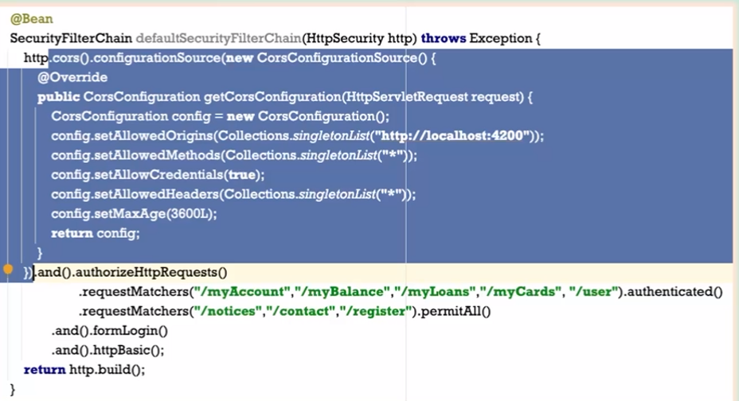

CSRF attack

When you login to particular site say NETFLIX after successful login netflix sends Jsession Id and stored in cookie browser so next time if user wants to access any page then with the help of cookie he can navigate he don’t have to login every time. But there is probm this could lead to CSRF attack say you opened another site where you see an ad and you click on it internally hacker has written an code to change the Netflix username and since session id is already present then nextflix will execute this request.

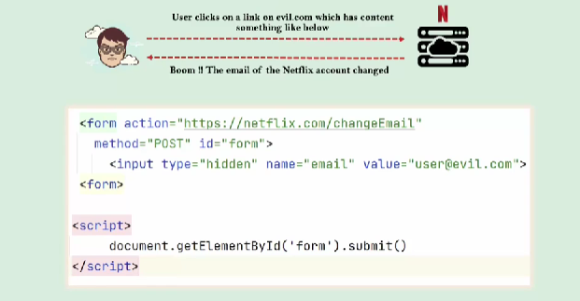

To avoid this we can make use of randomly generated CSRF token for this particular user session and is inserted within the hidden parameters of html forms to avoid exposure to session cookies.

By default spring security is not going to provide csrf restrictions for get API as its oly used to fetch the data. And we can disable csrf security to few APIs by ignoring them as below.

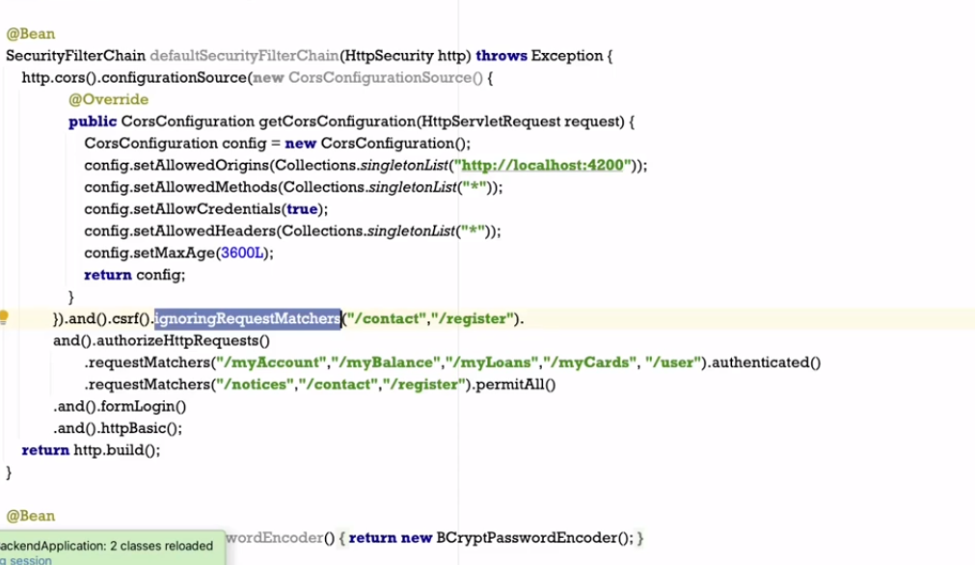

CSRF solution we need to make few changes where we are creating SecurityFilterChain. We need to create an Object of CsrfTokenAttributeHandler which is responsible for generating csrf token and pass it as hidden param

Also while sending from UI this token needs to be in added in header parameter X-XSRF-TOKEN

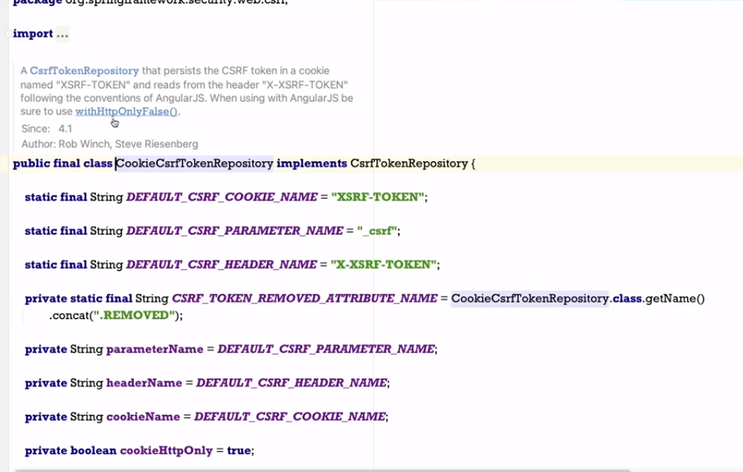

We also need to create a filter so that backend can send this token in response to the UI application

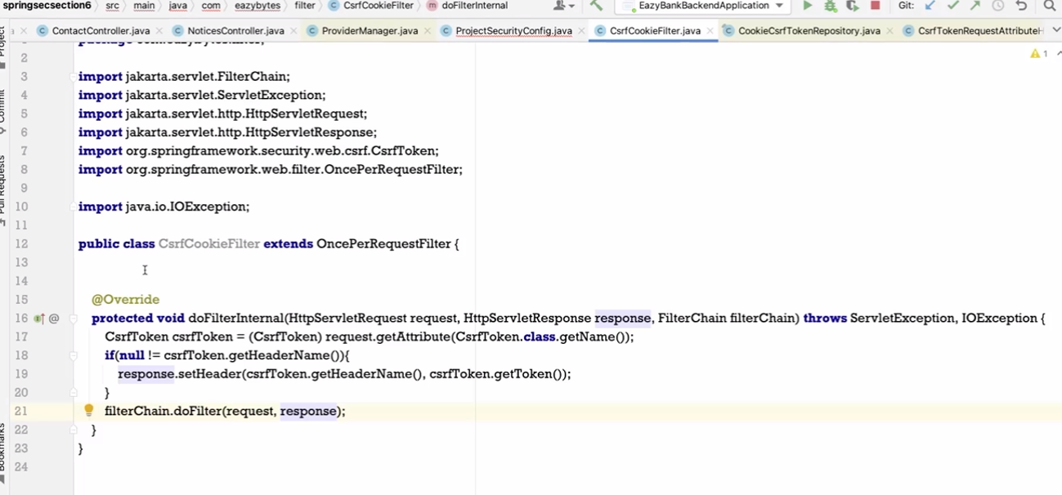

We need to register this filter with spring security

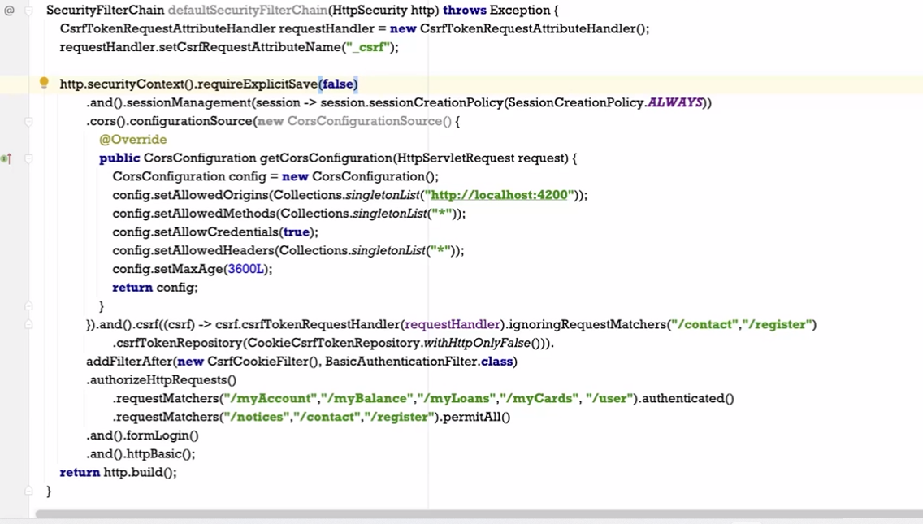

withHtttpOnlyFalse so that JS code inside Angular can read that cookie value

Next is you may have question how for custom login form how spring security is able to get username and password. From Angular it is being sent in Authorization headers using basic authentication principle as below

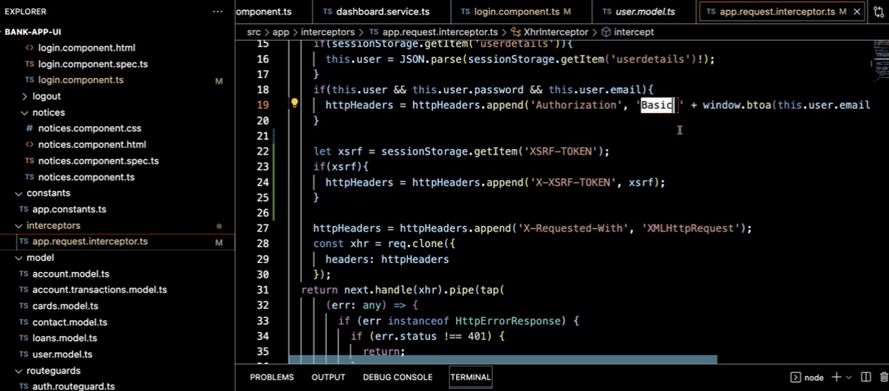

This informs spring security to use default basic authentication filter its inbuilt file provided by spring security as below

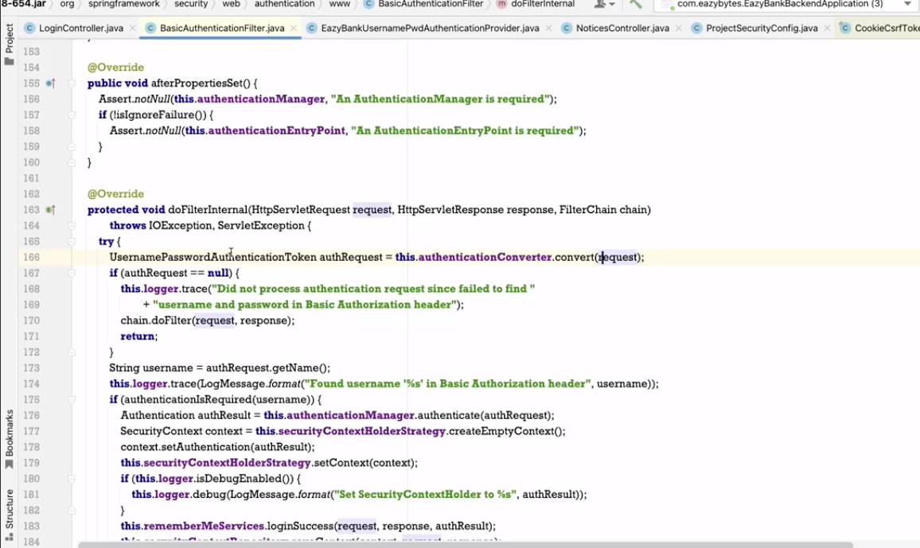

Which then constructs an Authentication object that contains username and password details

**Authorization** determines which all resources the end user can access for eg Admin user can have extra access to the resource which other users like customers don’t have. Now lets see how this authorities are stored in Spring security. Authorities are stored in GrantedAuthority and spring provides sample implementation on interface as below

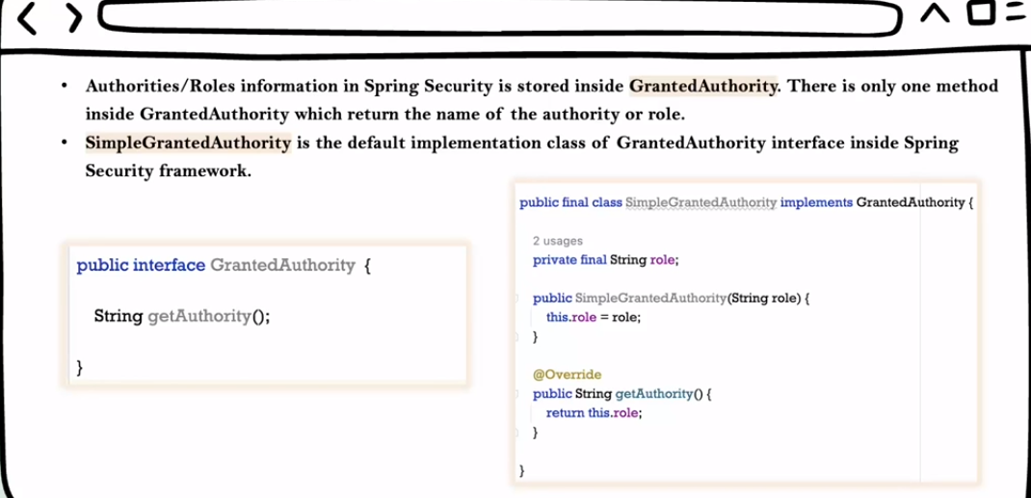

Whenever UsernamePasswordAuthenticationToken or User object is created internally spring calls getAuthorities() method. We are passing authority in Authentication provider.

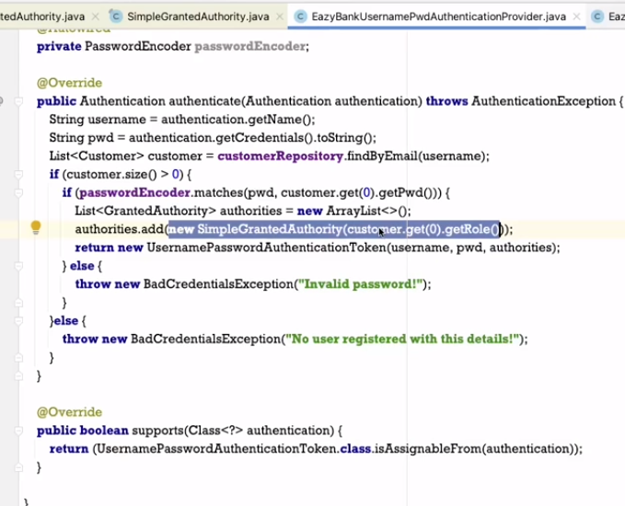

Spring security also define multiple roles for single user . lets create a new table authorities so that multiple authorities can be assigned to single user.

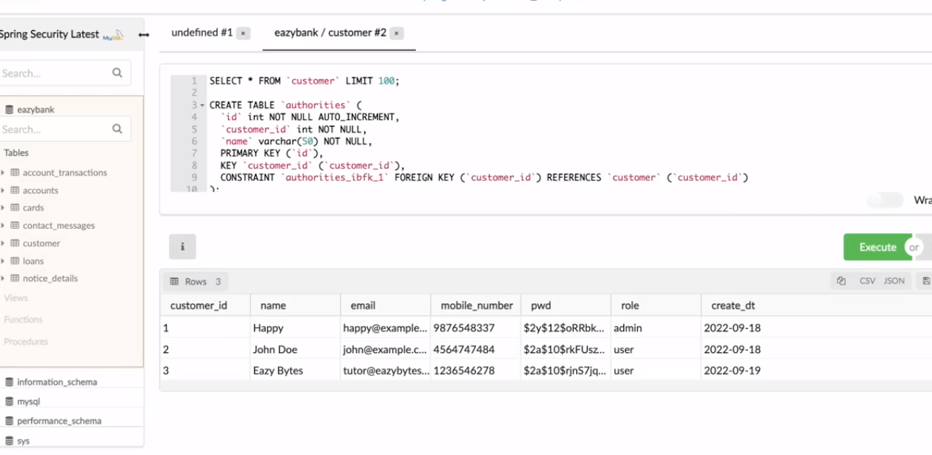

https://www.w3schools.com/sql/sql_foreignkey.asp

Now for customer we have added few authorities as below for customer Happy

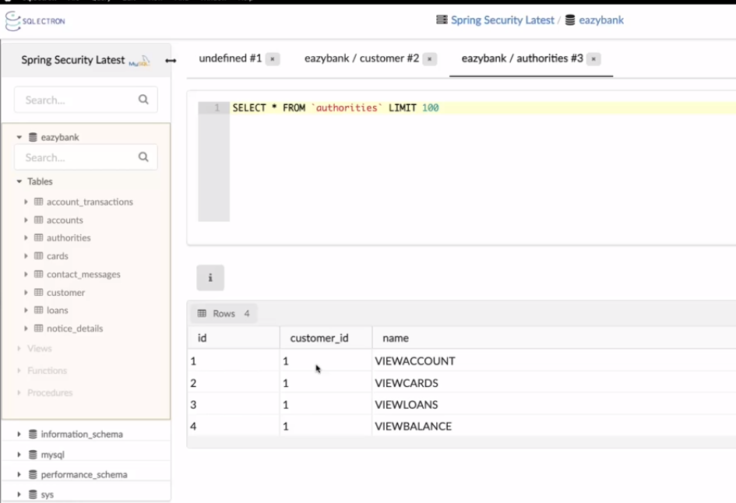

Similarly created Entity

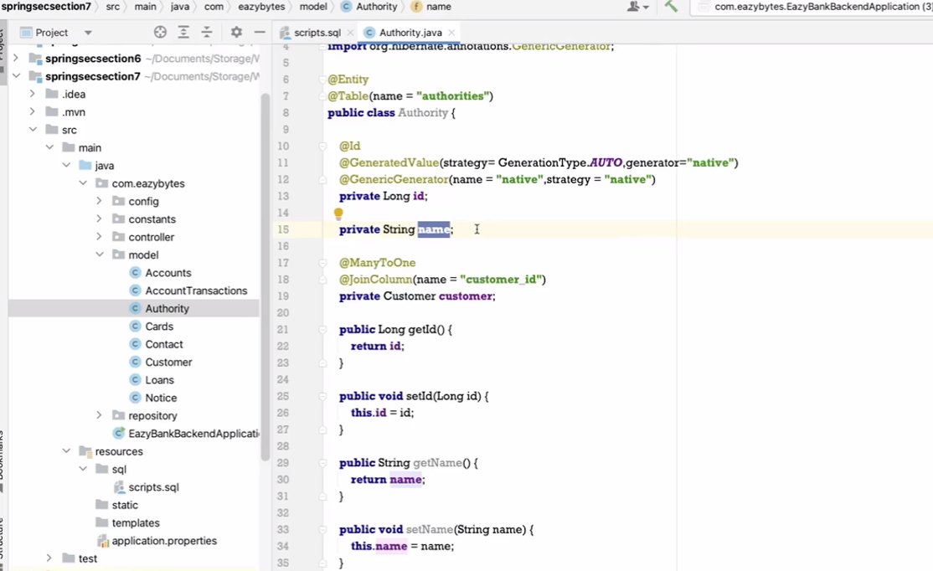

For code chk github,, In security filter chain bean creation add the authorities as below

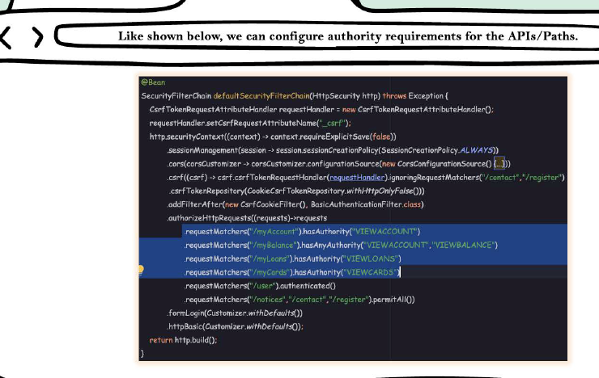

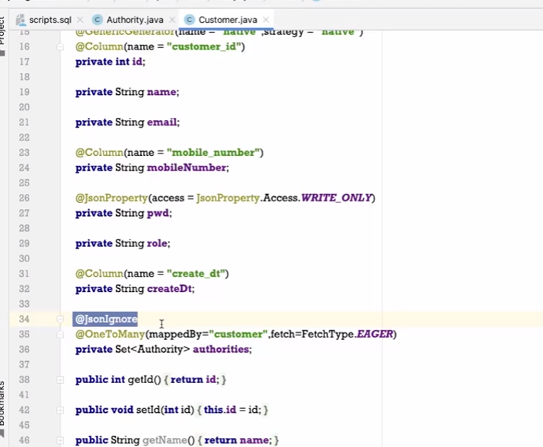

Jsoningnore annotation tells spring that we donot have to send authorities in response therefore response object doesn’t contains authorities field

Now lets make changes in our custom AuthenticationProvider class by creating getGrantedAuthorities that creates a list of simplegrantedauthority object

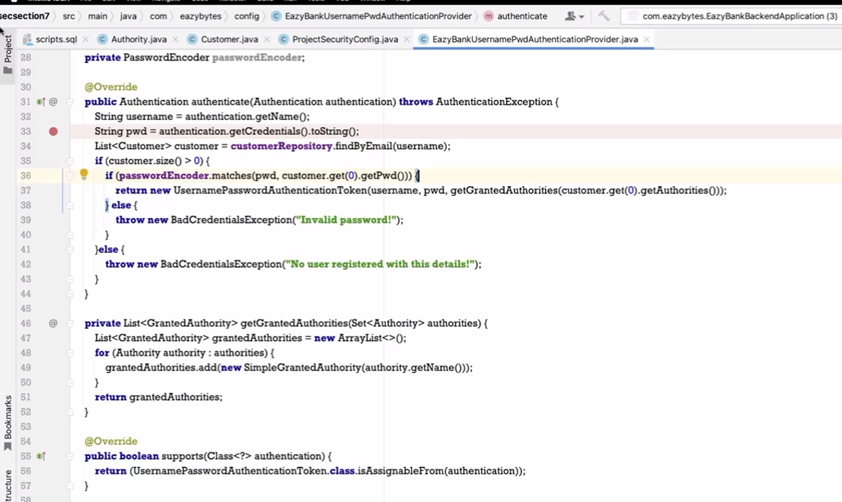

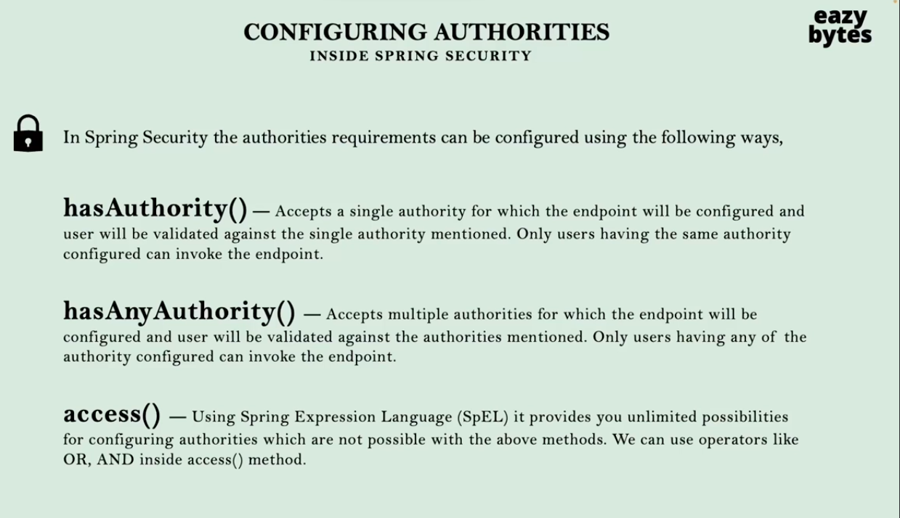

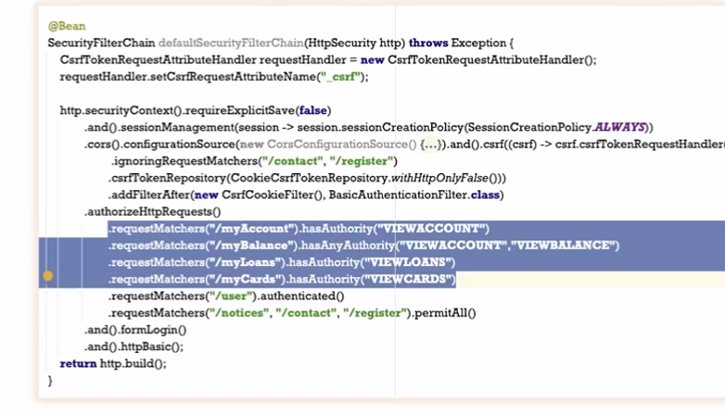

If we don’t want authority / role related features then simply we can make them authenticated

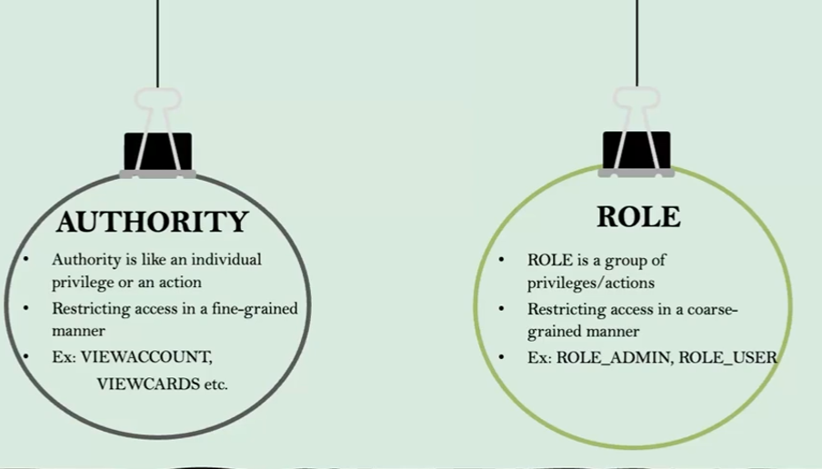

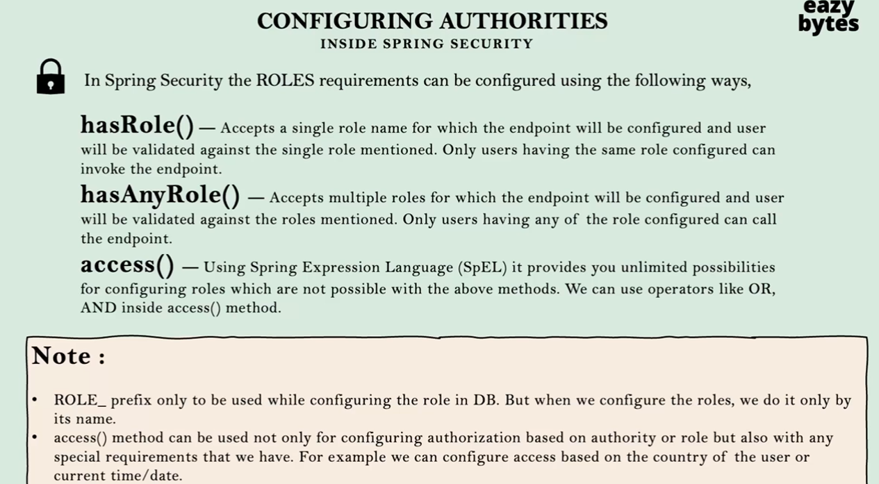

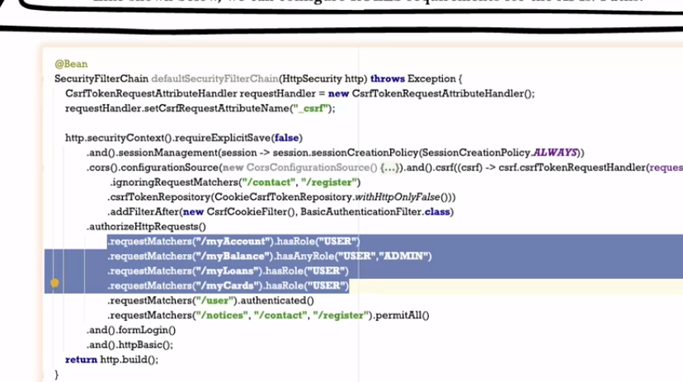

Spring Security Filter

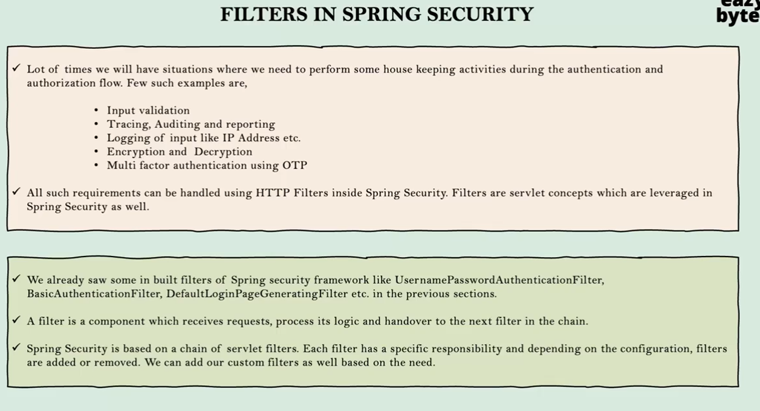

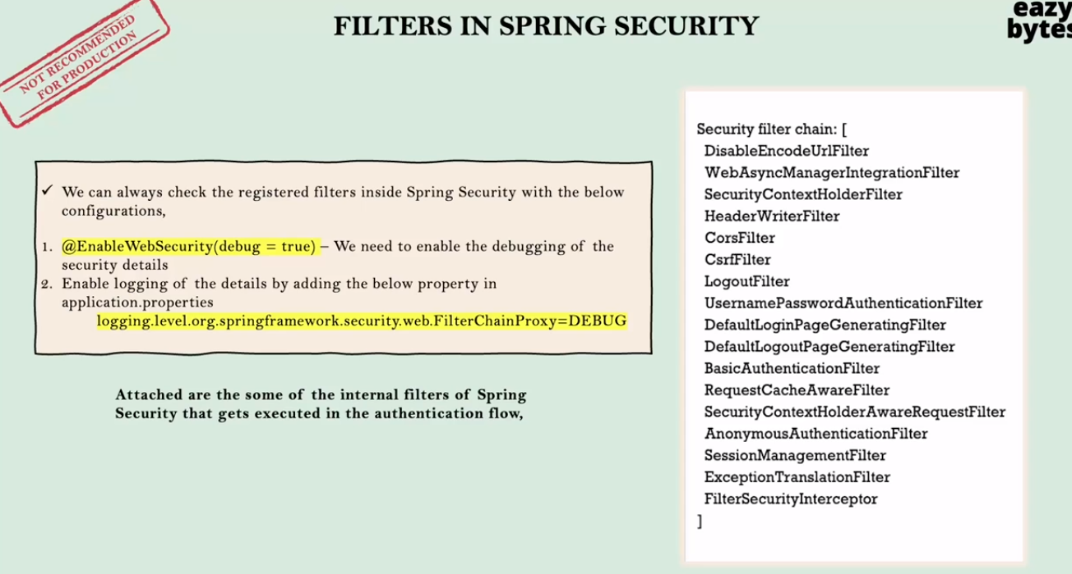

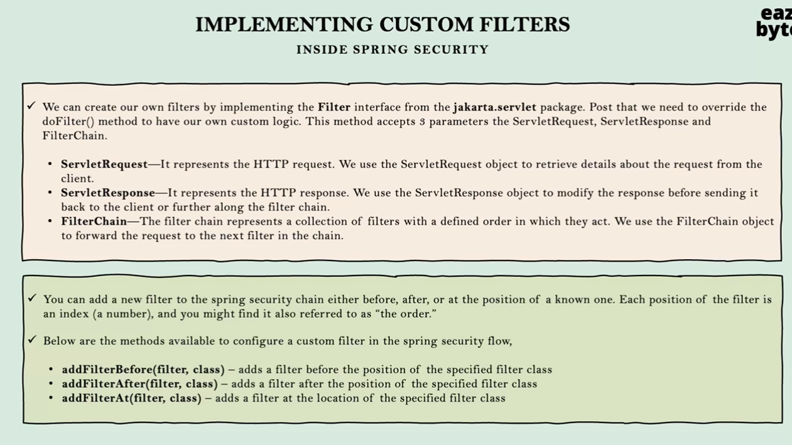

**There are many existing filters which works in hand in hand with other filters meaning that filters are chained . filters will execute one after the after. So if we create custom filter we need to add it before or after the particular filter as in below diagram**

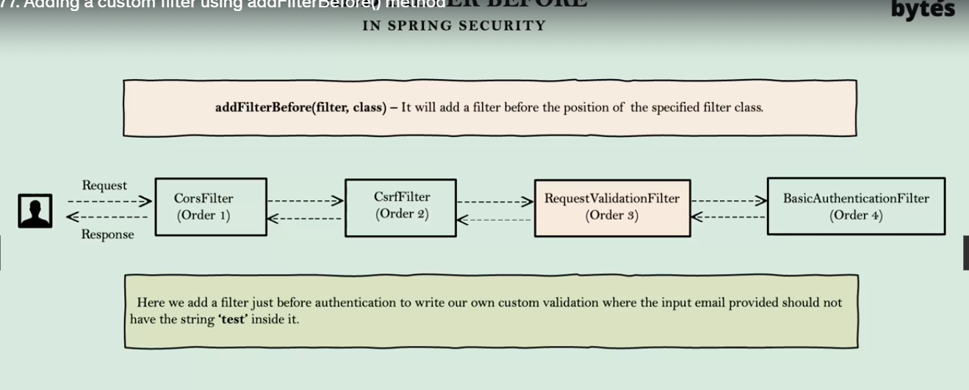

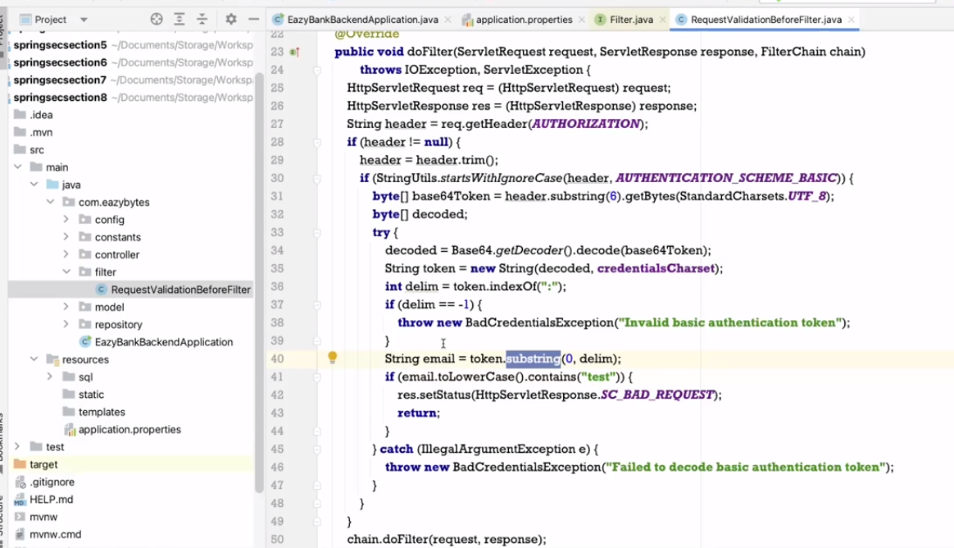

**Now add this filter before BasicAuthenticationFilter class we add filter info in SecurityFilterChain configuration method**

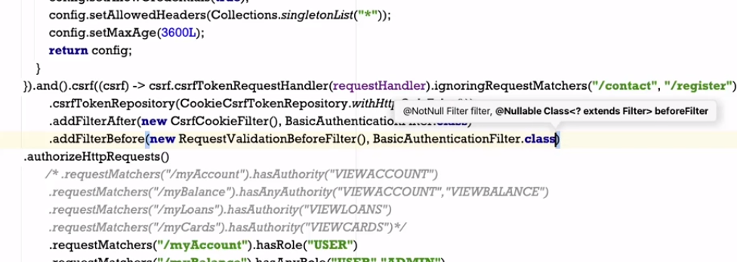

**Now lets see example of adding filter after a particular filter and perform some operation after successful login that is to log details of logged in used on console. We can get user info from Authentication object as after successful validation Authentication object is placed in security context.**

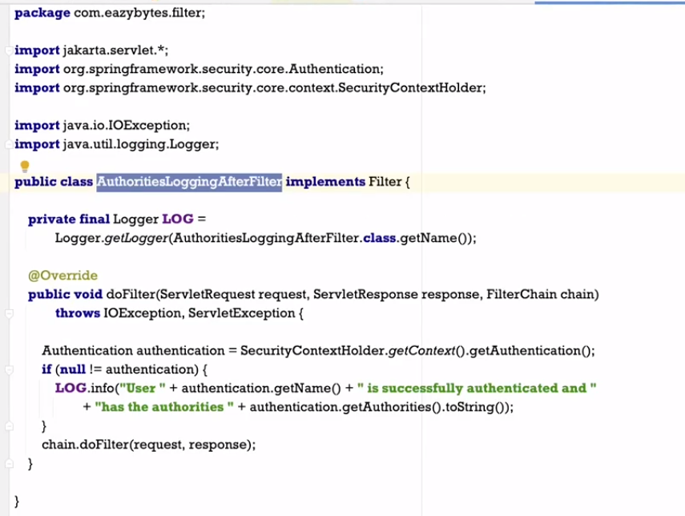

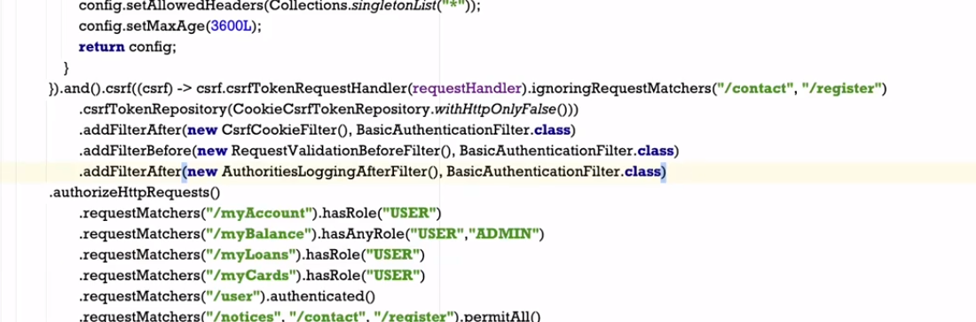

**For code check on git hub section 8**